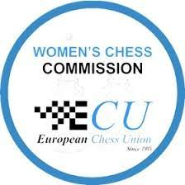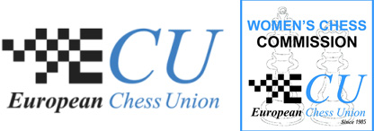

Date & Time: 23rd August 2025, 13:00 – 16:30 CET
Location: Online Webinar with IM Jop Delemarre
Intended Audience:
This session is designed for women who are either experienced trainers or interested in developing their training skills.
Objective:
Participants will learn how to foster effective and engaging learning environments through best practices in group management and cooperative working methods.
Part 1: Group Management (13:00 – 14:30 CET)
- Learn strategies for organizing your classroom to maximize learning outcomes.
- Explore methods for establishing and maintaining effective rules.
- Develop routines and habits to promote productive, low-stress classes.
*A 15-minute break will follow.*
Part 2: Cooperative Working Methods (14:45 – 16:30 CET)
- Discover leading cooperative techniques to enhance student collaboration.
- Understand how to model positive behaviors as an inspiring educator.
- Gain practical, classroom-tested strategies to enhance lesson delivery.
Whether you are beginning your journey or seeking to refine your skills, this session offers tools, insights, and inspiration to enrich every lesson.
Registration for Women Across Europe:
Please email your full name along with your FIDE profile or national player profile to
Aga Milewska, ECU Councilor, at womenchess@europechess.org.
Attendance is limited to 25 participants, who are required to have their cameras on during the Zoom session to facilitate interaction with the topics discussed.
Women interested only in viewing the recording after the event are also encouraged to contact us via email. Please note that a recording of the workshop will be published on our website following the session.

